Pagina About

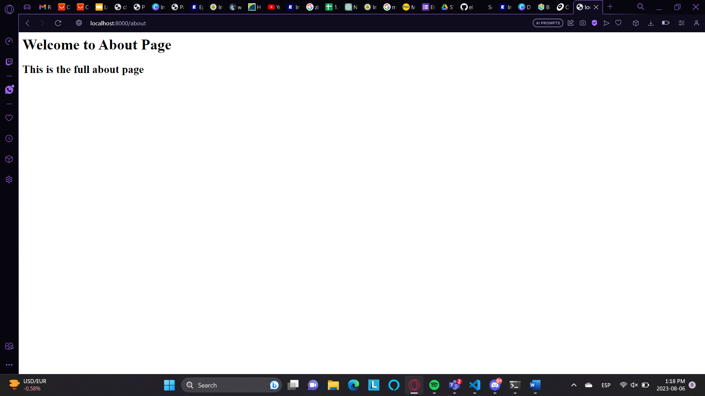

Pagina Home

Branch main

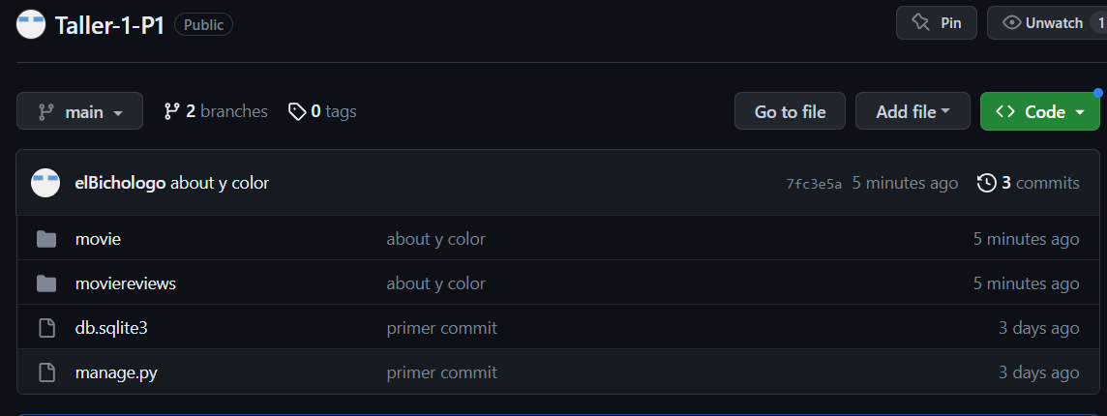

Branch development

